A sandbox player completed registration for Cumming Sharon Springs Singles through Easy Pay Direct. The card was entered in the provider secure field, the payment was verified by the backend, and the reservation changed to confirmed. No raw card details were stored by the application.
Test result
Step | Result | What was verified
League selection | Completed | The player selected Cumming Sharon Springs Singles at the NTRP 3.5 level.
Spot hold | Completed | One registration hold was created before payment to protect league capacity.
EPD card entry | Completed | The card was entered through the EPD secure card frame. The application received only a short lived token.
Payment and confirmation | Completed | The sandbox order completed and the registration screen showed Confirmed with a $35 fee.
Dashboard | Completed | The player dashboard listed the league as Confirmed and showed the registration confirmation panel.
Registration confirmation
The confirmation page records the specific league and its confirmed status. The completed registration retains the player snapshot, season, preferred court, and paid fee in the application. It does not expose card details or an EPD secret.
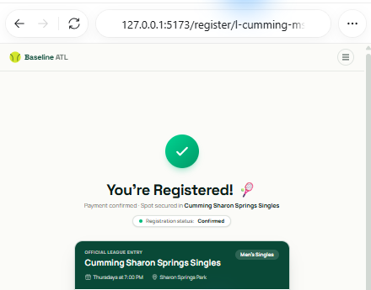
Figure 1. Confirmed registration in the Baseline ATL application. The screen shows Cumming Sharon Springs Singles and the confirmed registration status.

Confirmed player dashboard
After confirmation, the player dashboard displays the league within My Leagues and a separate registration confirmed panel. This shows that the confirmed registration remains available after leaving the payment page.
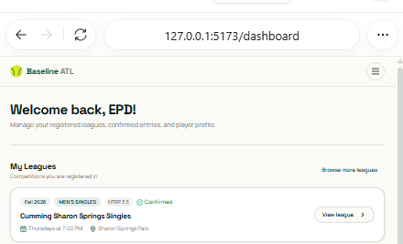
Figure 2. Player dashboard after Easy Pay Direct confirmation. The league appears as Confirmed in My Leagues.
Implementation note
Easy Pay Direct is selected with PAYMENT_PROVIDER=ezpaydirect. The application uses EPD Elements for card entry, sends the resulting one time token to the backend, creates and verifies the provider order server side, and confirms the reservation only after verified payment status. Stripe, Worldpay, and mock remain selectable through the same environment variable.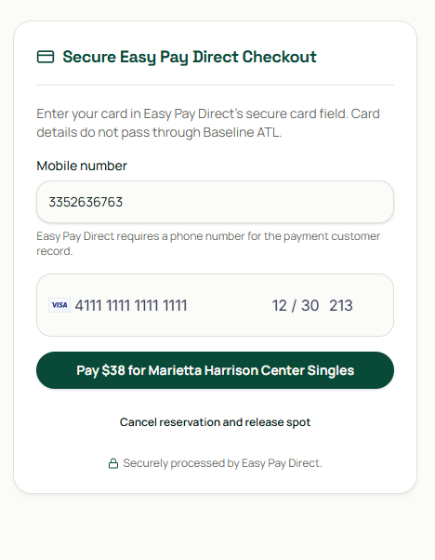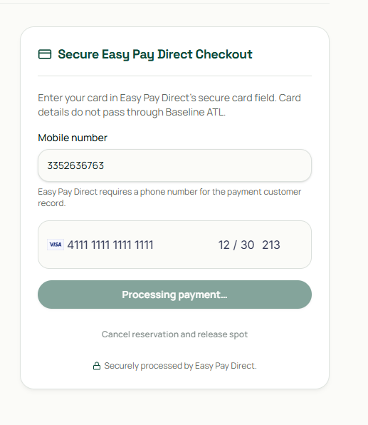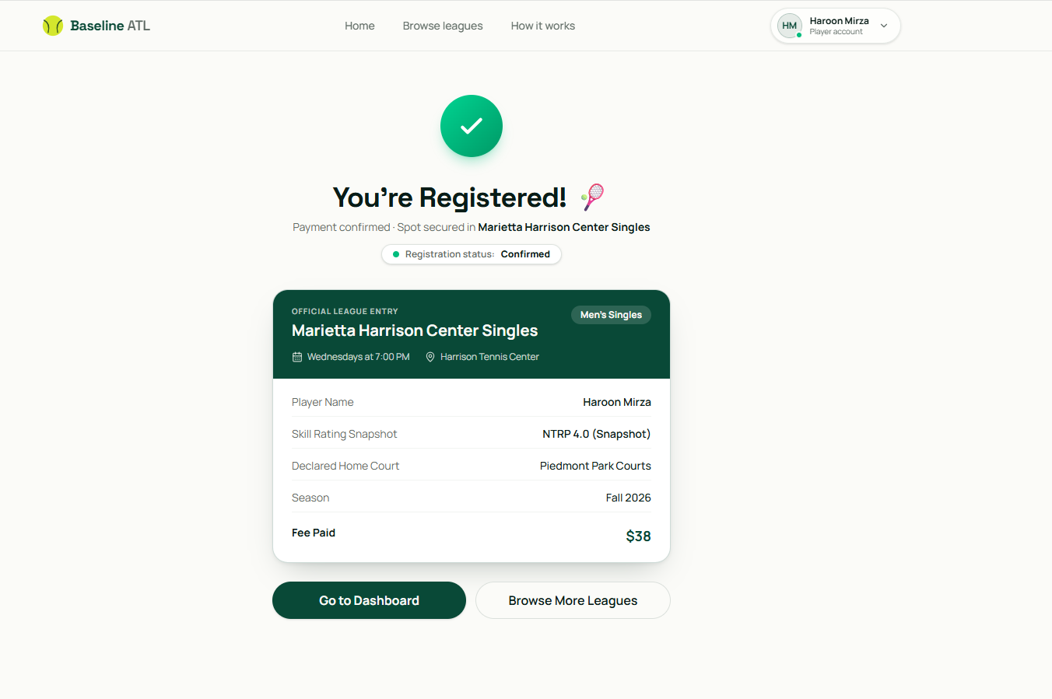

Easy Pay Direct technical integration validation
This section records the Easy Pay Direct work. It replaces any E2Pay provider conclusion. Easy Pay Direct is the provider assessed in this report. The earlier E2Pay work was for a different company and is not used as validation for Easy Pay Direct.
Implementation status
Requirement | Status | Implementation or boundary
Easy Pay Direct sandbox registration | Implemented | EPD Elements tokenizes card data in the browser. The backend creates and verifies the order before confirming the reservation.
Provider selection | Implemented | Set PAYMENT_PROVIDER=ezpaydirect, stripe, worldpay, or mock. Exactly one provider is active for a deployment.
Stripe to Worldpay automatic fallback | Not built | No automatic provider switching is present. It remains research and development work and is outside this build.
Season operating state | Implemented | A season records active season, off season, or standby. New reservations are blocked unless the season is active season.
Season One categories | Implemented | Configurable category records support Men’s Singles, Women’s Singles, Men’s Doubles, Women’s Doubles, Mixed Doubles, Junior Singles, and Junior Doubles.
City based divisions | Implemented | City division records link a season, city, category, optional skill level, and associated leagues.
Manual playoff preference | Implemented | A player can record an opt in or opt out for a city division. This is a preference record only.
Automated standings and brackets | Not built for V1 | Standings, qualification, and bracket placement remain manual organiser work.
Easy Pay Direct payment flow
A player selects an open league and the backend creates a timed reservation before any payment is attempted. This temporarily reduces the remaining capacity and prevents duplicate active reservations for the same player and league. The browser uses the Easy Pay Direct secure card field to create a one time card token. Raw card data is not sent to or stored by Baseline ATL.
The backend uses the server side Easy Pay Direct sandbox key to create the customer, product, payment method, and order. It applies an idempotency key to these provider requests. The reservation is confirmed only after the provider order is verified as paid. The existing figures show the completed confirmation and the player dashboard after the confirmed registration.
This is direct card entry through EPD Elements within the application. It is not a hosted Easy Pay Direct redirect page. The embedded secure card field reduces the application’s card data exposure, but the merchant remains responsible for its Easy Pay Direct account, permitted business use, customer policies, refund decisions, and provider compliance requests.
Webhook and confirmation
The application includes the Easy Pay Direct webhook route at https://atlanta-tennis-staging.vercel.app/api/payments/ezpaydirect/webhook. It accepts only a time limited HMAC signed event and applies duplicate event protection before changing a reservation. The endpoint and signing secret must be configured in the Easy Pay Direct dashboard for the staging account. A captured provider delivery should be retained before any production payment claim is made. The completed sandbox confirmation in this report was verified through the payment flow and backend order verification.
Season and division data model
Season records now include operatingState. The permitted values are active season, off season, and standby. The reservation service permits new registrations only for an active season. Existing active legacy season records remain compatible until they are explicitly migrated to an operating state.
SeasonCategory records make the Season One categories configurable. CityDivision records store the city, category, optional skill level, current state, linked leagues, and a manual placement marker. PlayoffOptIn records store the player’s declared preference, the season, the city division, the person who captured it, the date, and an optional note. No code calculates rankings, standings, qualification, or playoff brackets.
Merchant record
New reservation records retain the merchant identity Hyper Nexus Group LLC and the operator Mr Saad Moudood. The spelling Moudood is used in the backend data model and payment related reservation records.

Deployment and verification
The implementation is deployed to the staging site at https://atlanta-tennis-staging.vercel.app. The frontend and backend TypeScript checks passed. The backend test suite includes model validation for operating state, category, city division, manual playoff preference, and the merchant identity snapshot.
The current staging payment configuration selects Easy Pay Direct with PAYMENT_PROVIDER=ezpaydirect and sandbox credentials. Credentials, signing secrets, and card data are not included in this report.
Provider observations
Stripe and Worldpay remain selectable alternatives through the shared payment provider interface. The recorded sandbox observation is that Stripe showed no observed errors and Worldpay showed one to two sandbox errors. This is a test observation only. It does not establish production reliability, automatic provider fallback, or a final provider decision.
Remaining production checks
- Configure the staging webhook endpoint in the Easy Pay Direct dashboard and retain one signed delivery record.
- Run the provider’s approved production onboarding, business verification, and live payment test before accepting live player funds.
- Keep refund and dispute handling under explicit provider approval and merchant policy. Automated rankings and playoff bracket generation are not part of V1.

